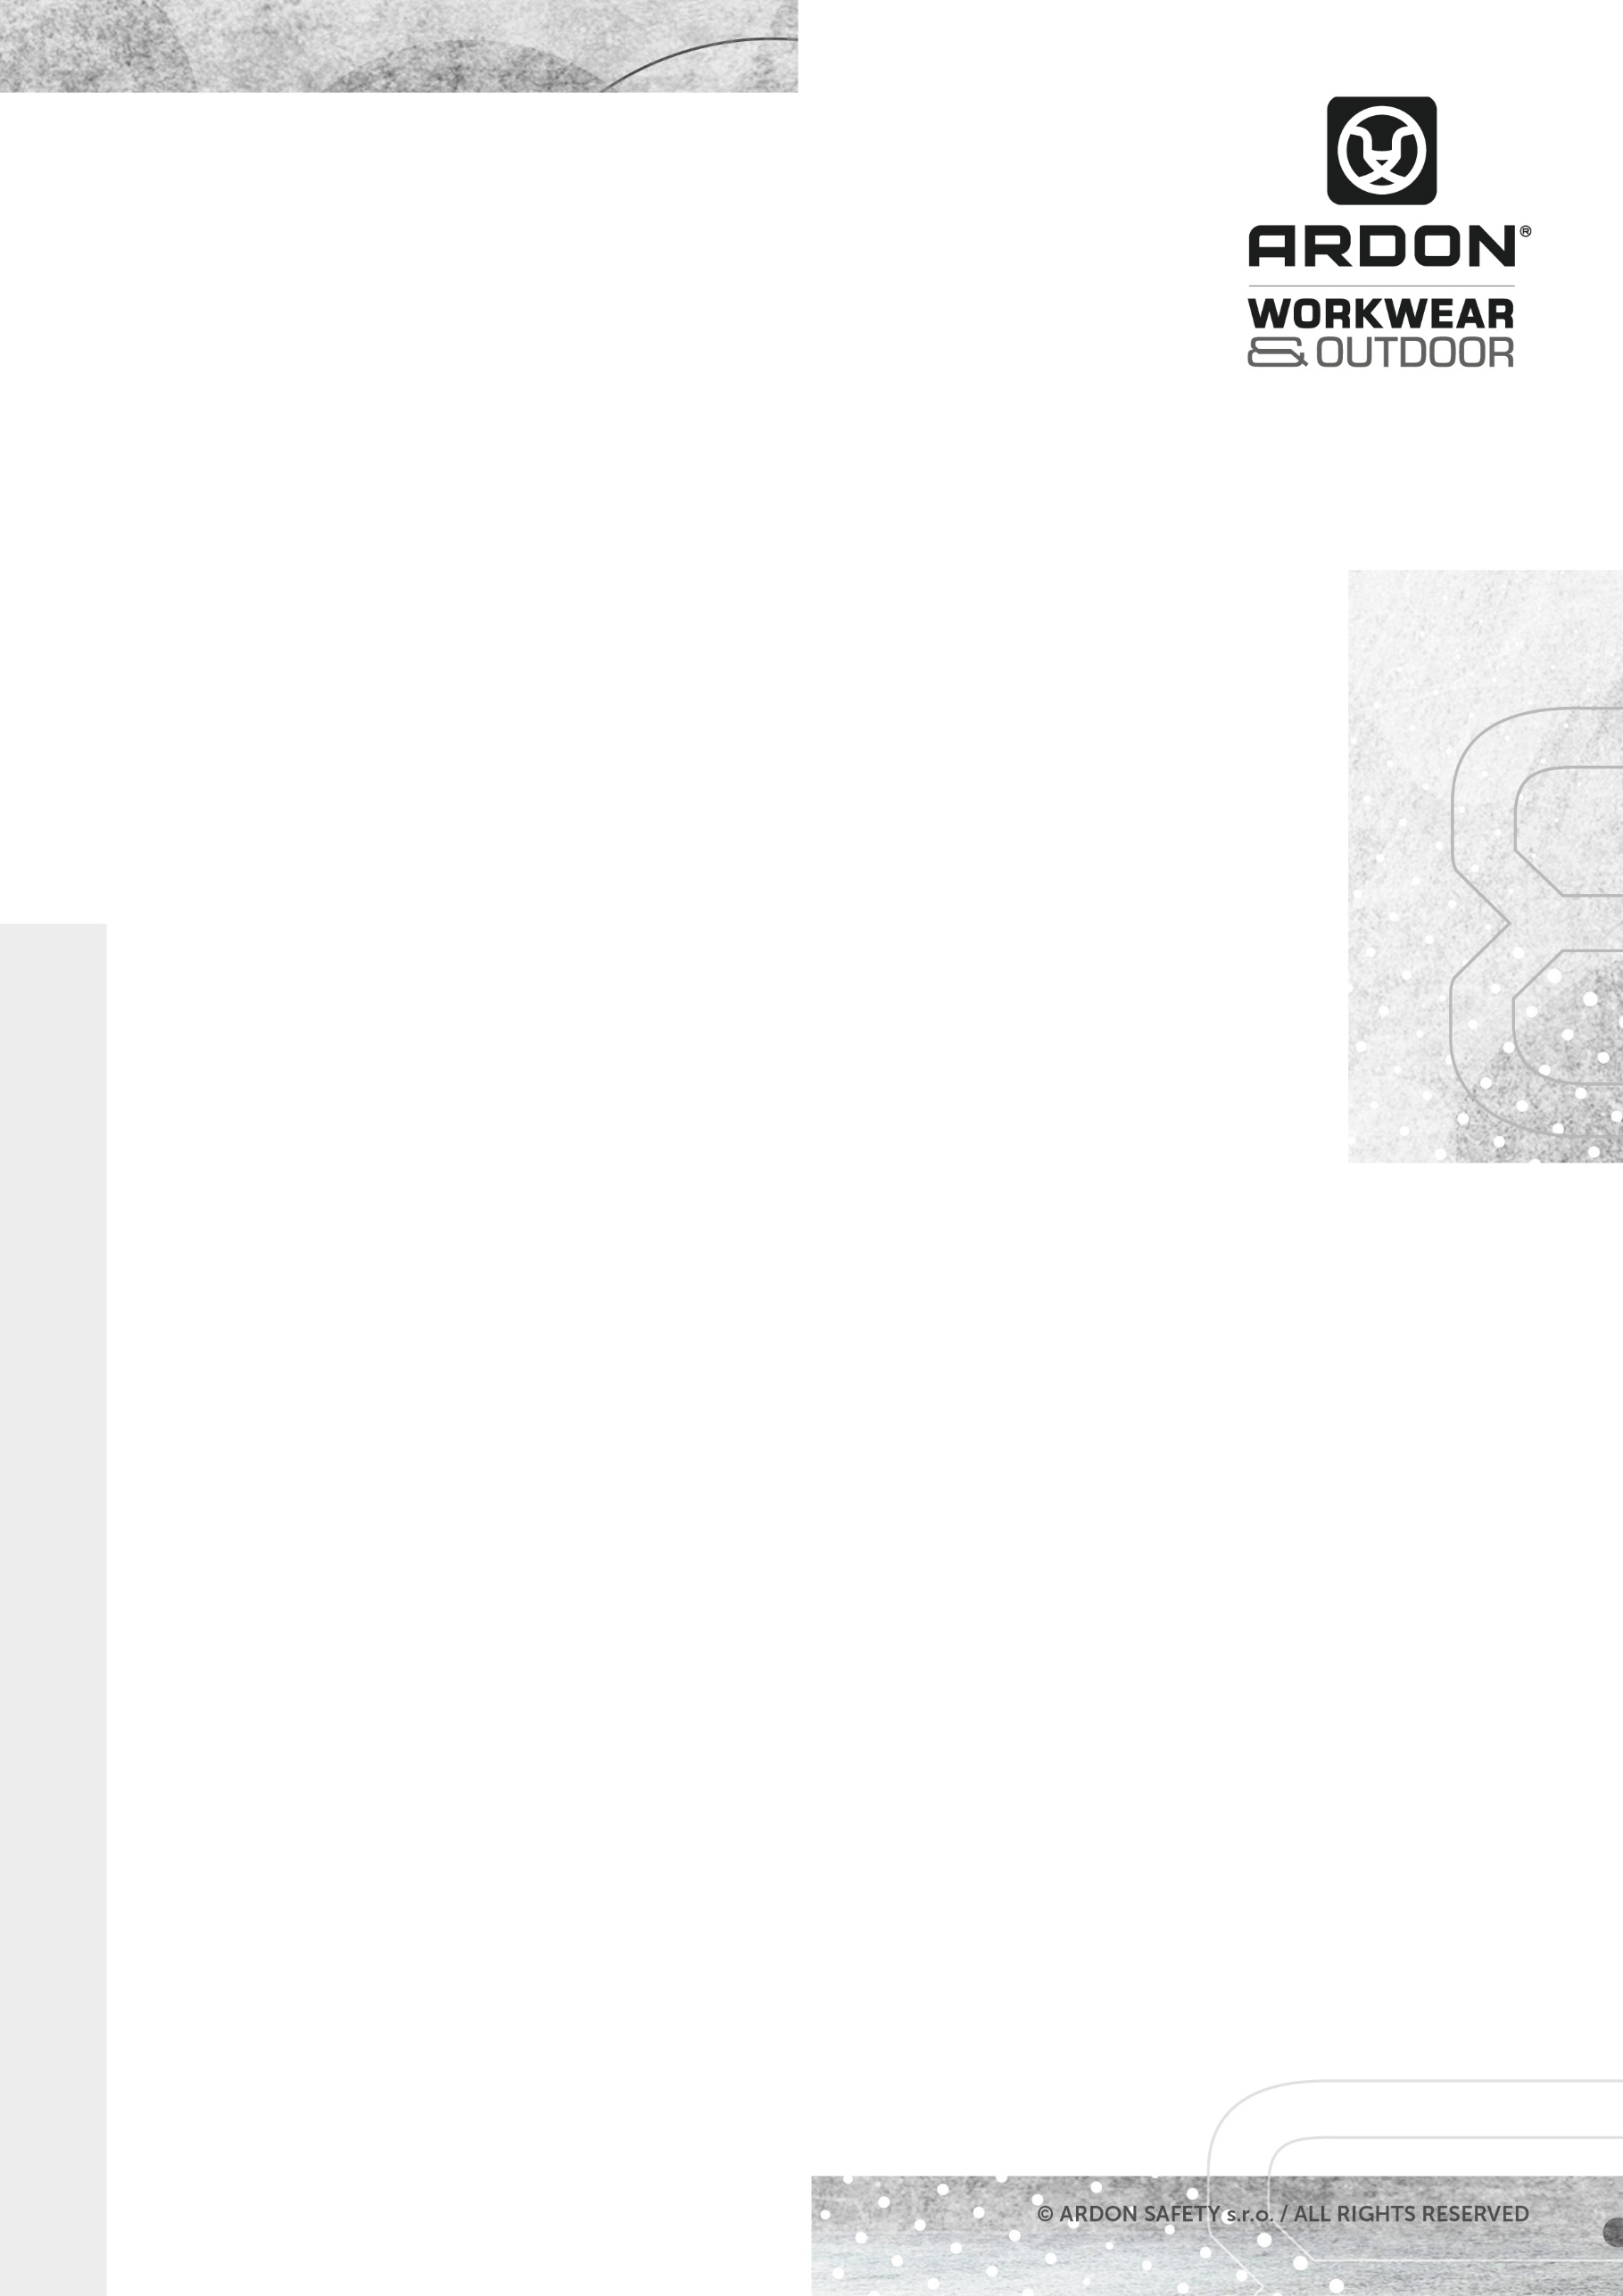
ARDON®CITYCONIC
SWEATSHIRT

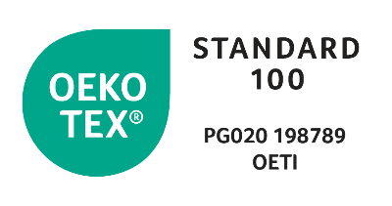
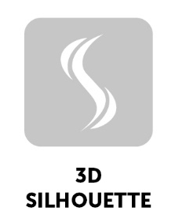
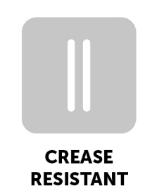
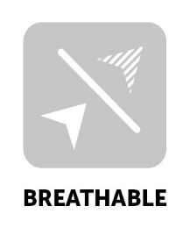
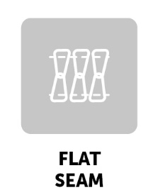
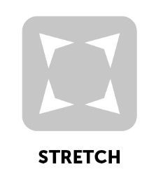
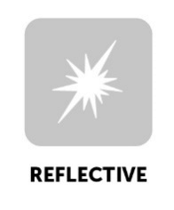
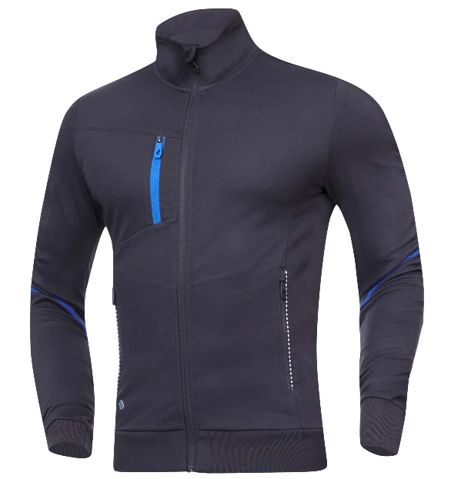
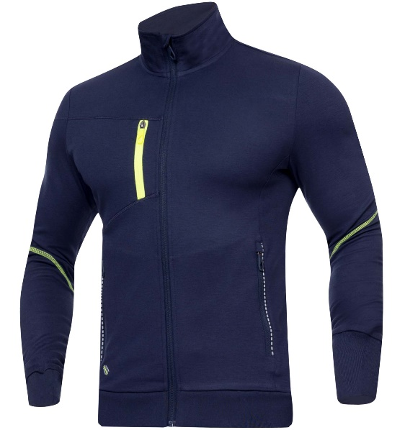
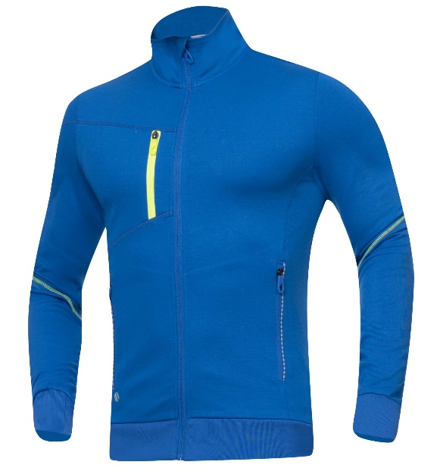
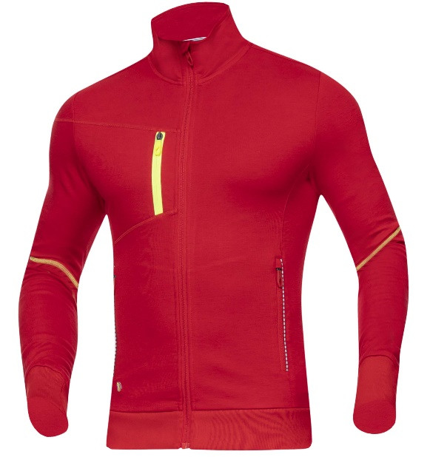
TECHNICAL DATA SHEET
ARDON®CITYCONIC
SWEATSHIRT
ARTICLE H6683 (red)
H6682 (blue)
H6684 (dark blue)
H6681 (dark gray)

MATERIAL ARDON®TOPLYRON, 68 % rayon, 27 % nylon, 5 % spandex
GRAMMAGE 280 g/m²

SIZE XS-4XL H6683, H6682
S-4XL H6684, H6681

DESCRIPTION
This stretch sweatshirt with a stand-up collar made of the ARDON®TOPLYRON technical material, which is of extreme high quality, keeps a stable shape, and is wrinkle-free and pleasant to the touch at the same time. The material is not susceptible to static electricity due to its ability to repel dust particles. The sweatshirt has an anatomically shaped functional SLIM FIT cut, is equipped with a comfortable continuous zip fastening with a chin guard, 1 zipper chest pocket and 2 zipper side pockets. The chest pocket is located on the right side to allow for branded printing. For increased safety of movement, the sweatshirt has functional high-visibility elements.

This personal protective equipment is in conformity with the requirements of the following harmonised standard:
TECHNICAL DATA SHEET

ČSN EN ISO 13688:2013 – Protective clothing - General requirements
PPE of simple design against the minimum risks that may be quickly
and safety recognised by the user.

The self-certification was carried out on the basis of the technical documentation of the product and practical tests of ergonomics propreties of the product by Ardon Safety s.r.o. on 20 January 2021.

The CITYCONIC Collection meets health requirements and is OEKO-TEX®Standard 100 certified, PG020 certificate 198789 OETI.

NUMBER OF PIECES IN CARTON 20 pcs
CARTON WEIGHT 13 kg
CARTON SIZE 0,79 m³
UNIT PACKAGING 1 pc

The service life depends on the rate of use and the rate of wear in the given
conditions. Inapropriate storage conditions, improper maintenance and care
reduce the service life. The warranty period is 24 months. Under no circumstances
should the warranty period be confused with the service lefe of the product. With
Intensive use, the service life may be shorter than the warranty provided.

The product does not contain any substances in concentrations that are known or
suspected to have an adverse effect on the user´s hygiene of health. However, skin
irritation is not impossible for sensitive people, in which case do not continue to
use the garment. Avoid the fire and sources of intense heat. No accessories or
replacement pants are intended for these garments. If the garment is not in use, it
Is recommended to store it in a dry and well-ventilated area away from direct
Sunlight. Transport best in original packaging, protect from moisture and extreme
temperatures. Dispose ecologically after use.

TECHNICAL DATA SHEET
TECHNICAL DATA SHEET

