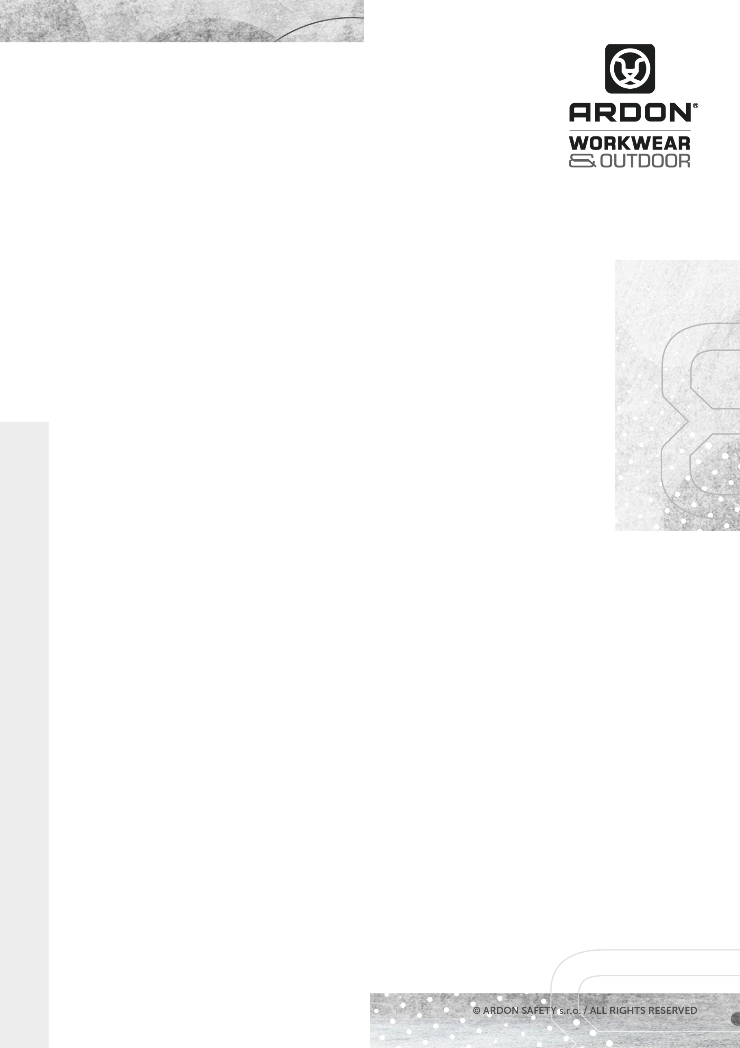


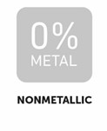
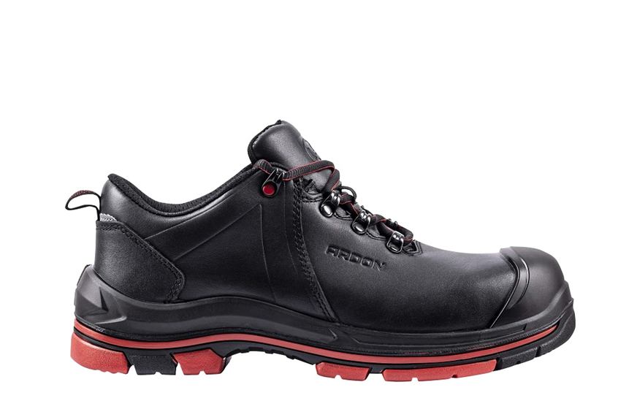

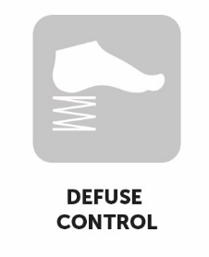

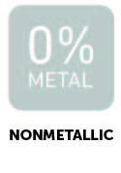
ARDON®SPARKLELOW S3
SAFETY SHOES

TECHNICAL SHEET
DIMENSIONS | 37-39 | 40-43 | 44-48
Carton H x W x D (cm) | 31.5 x 41.5 x 61.5 | 33.5 x 43.5 x 61.5 | 37 x 43.5 x 64
Carton (cbm) | 0,0804 | 0,0896 | 0,103

ARDON®SPARKLELOW S3
SIZE

UNIT

PACKAGE
Units in a carton
Units in a box
37-48

pair
10 pairs
1 pair

DESCRIPTION
Safety shoes with upper made of high-quality full-grain leather, leather tongue and ankle area, with hydrophobic treatment, with composite toe cap and Kevlar insole. The sole made of PU/rubber material has anti-slip SRC properties, is resistant to contact heat up to 300°C, provides insulation against heat and cold.
Size EUR | 35 | 36 | 37 | 38 | 39 | 40 | 41 | 42 | 43 | 44 | 45 | 46 | 47 | 48 | 49 | 50 | 51
Insole length mm | - | - | 244 | 250 | 257 | 264 | 270 | 277 | 284 | 290 | 297 | 304 | 310 | 317 | - | - | -
Foot length cm | - | - | 23,9 | 24,5 | 25,2 | 25,9 | 26,5 | 27,2 | 27,9 | 28,5 | 29,2 | 29,9 | 30,5 | 31,2 | - | - | -

Full grain cowhide 1.8 – 2 mm thick, hydrophobic treatment
MESH-type laminated breathable fabric
PU/rubber, direct injection
604 composite
Kevlar
ANATOMIC FOAM – anatomically shaped from EVA foam

MATERIAL
Upper
Lining
Sole
Toe cap
Plate
Insole

G3385
ARTICLE
SAFETY SHOES
TECHNICAL SHEET
TECHNICAL SHEET

NORMS

(EU) 2016/425
EN ISO 20345:2011 Personal protective equipment - Safety footwear

Category: S3 HRO SRC HI CI

Categories | EN ISO 20345
E - energy absorption in the heel area | ✓
FO - resistance to oils and fuels | ✓
A - antistatic footwear | ✓
SRC - resistance to slipping on ceramic floor tiles with SLS and on steel floors with glycerin | ✓
WR - upper resistant to water | ✓
Safety toe cap for toe protection | ✓
P - resistance to punctures (protective insole) | ✓
SRA - slip resistance ceramic floor tiles with SLS
HRO - resistance to contact heatup to 300 °C | ✓
insulation of the bottom of the shoe against heat | ✓
insulation of the bottom of the shoe against the cold | ✓
Splatters of molten metal
ESD – shoe protects against electrostatic discharge and can be used on EPA premises
The shoes do not contain metal parts | ✓
-
-
-



CODE | EAN | CARTON WEIGHT  (KG) | UNIT WEIGHT  (KG)
G3385/37 | 8592390163004 | 14.00 | 1.400
G3385/38 | 8592390163011 | 15.00 | 1.500
G3385/39 | 8592390163028 | 15.50 | 1.550
G3385/40 | 8592390163035 | 15.80 | 1.580
G3385/41 | 8592390163042 | 16.00 | 1.600
G3385/42 | 8592390163059 | 17.00 | 1.700
G3385/43 | 8592390163066 | 18.00 | 1.800
G3385/44 | 8592390163073 | 18.50 | 1.850
G3385/45 | 8592390163080 | 19.00 | 1.900
G3385/46 | 8592390163097 | 19.50 | 1.950
G3385/47 | 8592390163103 | 20.00 | 2.000
G3385/48 | 8592390163110 | 21.00 | 2.210

TECHNICÝ LIST

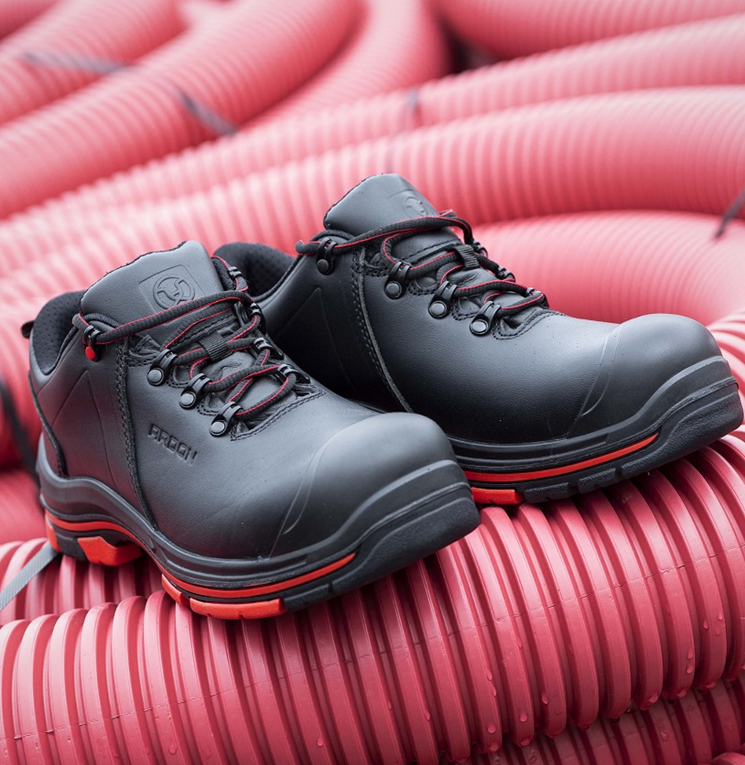

TECHNICÝ LIST

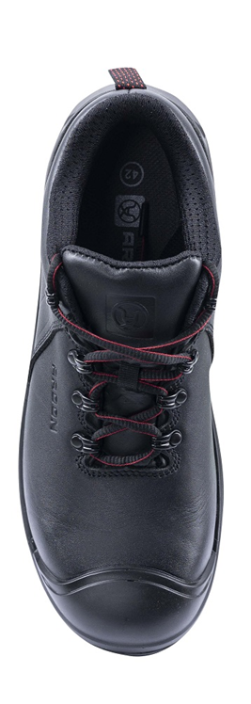
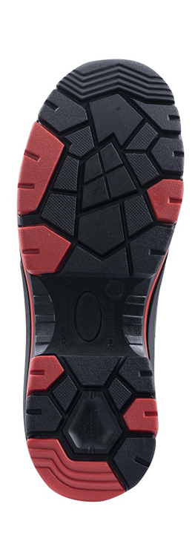

TECHNICAL SHEET

